Circuit Analysis (Lab # 6)

Experiment 6: VERIFICATION OF KIRCHHOFFS LAWS

Name: Muhammad Zia Ur Rehman Zahid Registration No: 2025-CE-104

Date: 22-April-2026 Grade and Signature: ………………………
CLO2  CLO3 | Use with identification the circuit components, breadboards,  multimeters, power supplies, signal generators, and oscilloscopes. Make measurements in their own constructed electric circuits.
Psychomotor/Affective | Level1 (1) | Level2 (2-3) | Level3 (4-5) | Level4 (6-7)
Report Marks (3) |  |  | Total marks (10)

Objective
To verify Kirchhoff’s current law and Kirchhoff’s voltage law for the given Circuit.

Apparatus Required
Sr. no | Apparatus | Range | Quantity
1 | Regulated Power Supply | Standard | 1
2 | Signal Generator | Standard | 1
3 | Oscilloscope | Standard | 1
4 | Digital Multimeter | Standard | 1
5 | Breadboard & Wires | Standard | As Required
6 | Resistors | 330ohm, 220ohm 1kohm | 3

Description
KCL: The algebraic sum of the currents meeting at a node is equal to zero.
KVL: In any closed path / mesh, the algebraic sum of all the voltages is zero.

Precautions:
- Voltage control knob should be kept at minimum position.
- Current control knob of RPS should be kept at maximum position.

Procedure for KCL:
- Give the connections as per the circuit diagram.

- Set a value in RPS.

- Note down the corresponding readings using multimeter

- Repeat the same for different voltages

Circuit - KCL
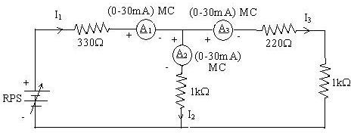

KCL - Practical Values:

Sl. No. | Voltage E | Current |  |  | I1 = I2 + I3
 |  | I1 | I2 | I3
 | Volts | mA | mA | mA | mA
1 | 5 | 5.68 | 3.12 | 2.56 | 5.68
2 | 15 | 17.1 | 9.37 | 7.68 | 17.1
3 | 25 | 28.4 | 15.6 | 12.8 | 28.4

Procedure for KVL:

- Give the connections as per the circuit diagram.

- Set a value in RPS.

- Note all the voltage reading

- Repeat the same for different voltages

Circuit - KVL
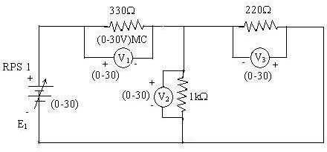

KVL - Practical Values

Sl. No. | RPS | Voltage |  |  | E1 = V1 + V2
 | E1 | V1 | V2 | V3
 | V | V | V | V | V
1 | 5 | 3.23 | 1.77 | 1.77 | 5
2 | 10 | 6.47 | 3.53 | 3.53 | 10
3 | 15 | 9.7 | 5.3 | 5.3 | 15

Result:
Thus, Kirchhoff’s voltage law and Kirchhoff’s current law are verified practically by performing this experiment.

Post Lab Questions

Define Kirchhoff’s current law.
Kirchhoff’s Current Law states that the total current entering a junction is equal to the total current leaving it.
It is based on the conservation of charge.
No charge is lost at a node in a circuit.

Define Kirchhoff’s voltage law.
Kirchhoff’s Voltage Law states that the total voltage around a closed loop is equal to zero.
The sum of all voltage rises equals the sum of voltage drops.
It follows the law of energy conservation.

What are the applications of regulated power supply?
A regulated power supply is used to provide constant voltage to electronic devices.
It is used in computers, mobile chargers, and lab equipment.
It protects circuits from voltage fluctuations.

What are the limitations of KCL?
KCL is not accurate at very high frequencies.
It does not consider the effect of electromagnetic fields.
It assumes no energy storage at the junction.

